**Your Name: Huruy Huruy Student ID: 100996468 Lab CRN: 75207**

NOTE: Please ensure to submit all Solidworks files in a zipped folder on the CAD link. The zipped folder should include ALL Solidworks assemblies, part and engineering drawings as specified in MDP 4 requirements.

**INSERT SCREEN IMAGE OF MULTI-VIEW SOLIDWORKS ENGINEERING DRAWING FOR PIVOT BLOCK**

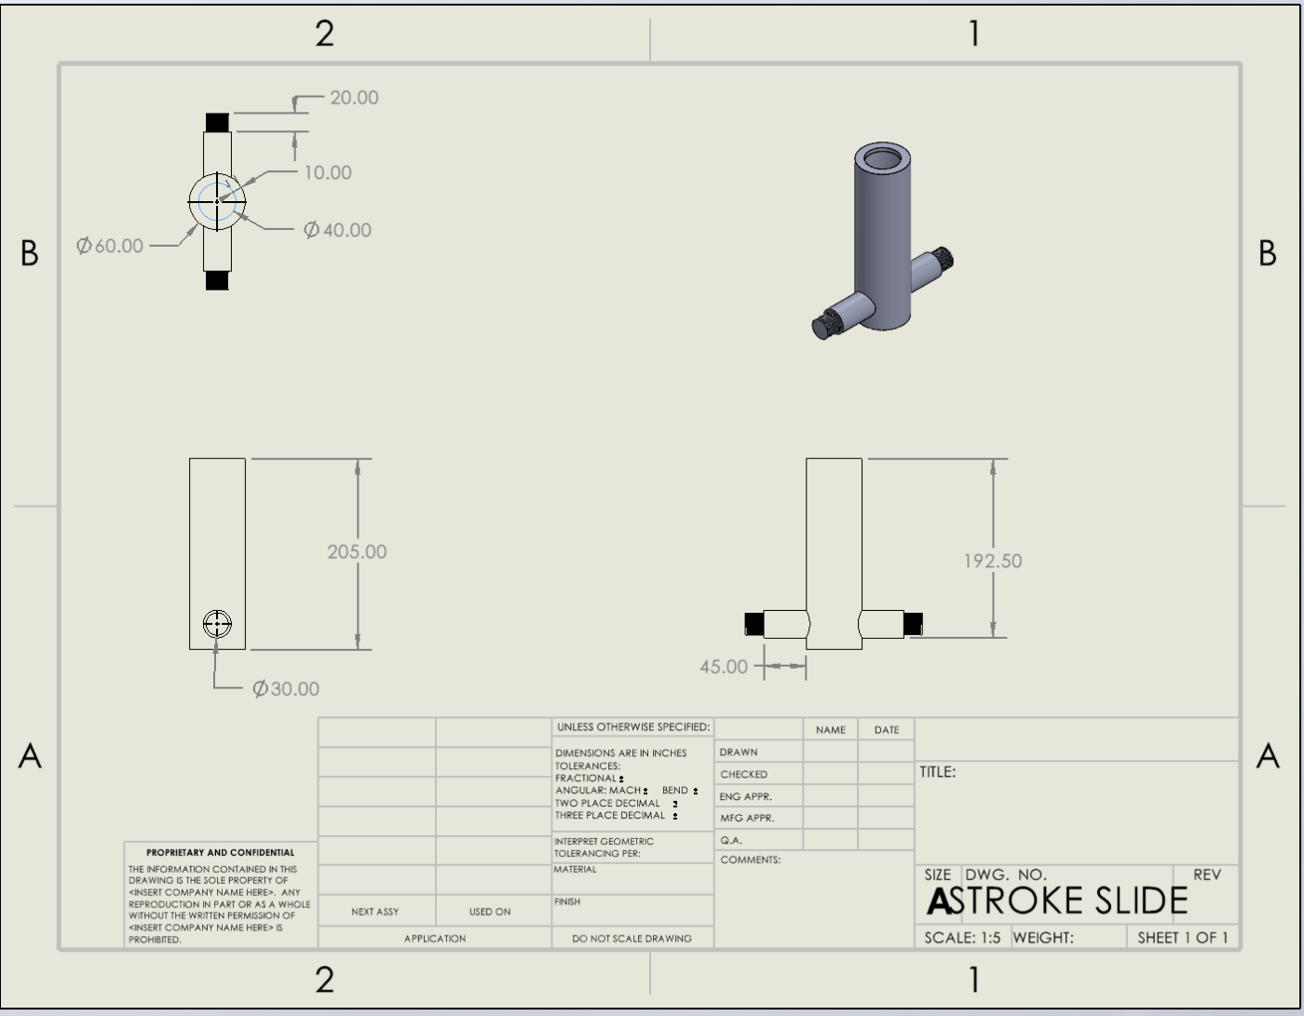

**INSERT SCREEN IMAGE OF MULTI-VIEW SOLIDWORKS ENGINEERING DRAWING FOR TEE**

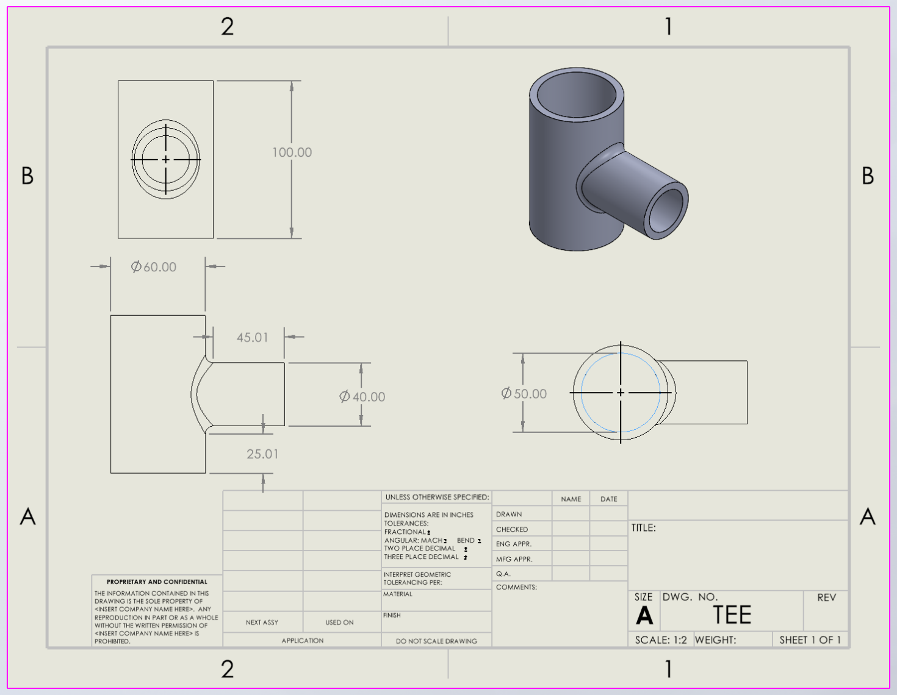

**INSERT SCREEN IMAGE OF MULTI-VIEW SOLIDWORKS ENGINEERING DRAWING FOR STROKE SLIDE**

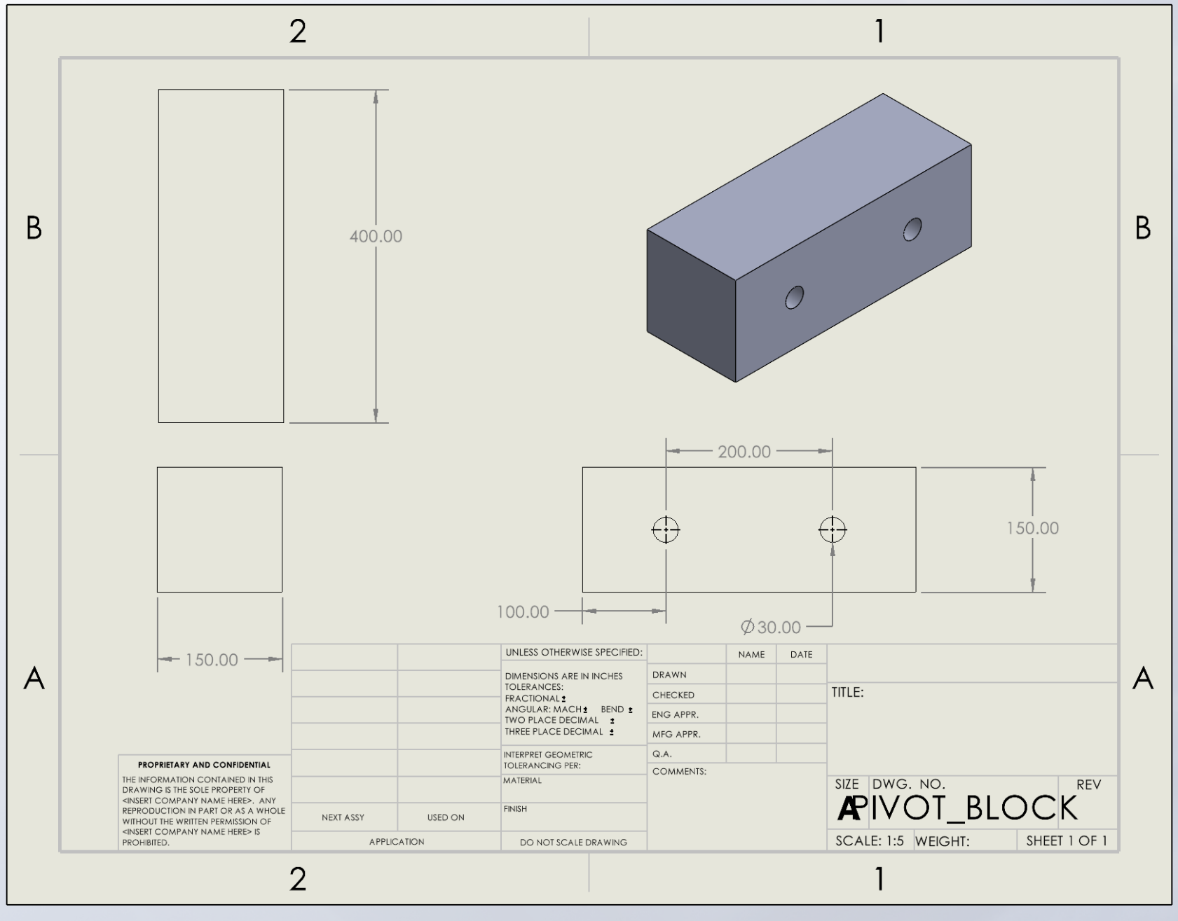

**INSERT SCREEN IMAGE OF MULTI-VIEW SOLIDWORKS ENGINEERING DRAWING FOR 30MM BOLT**

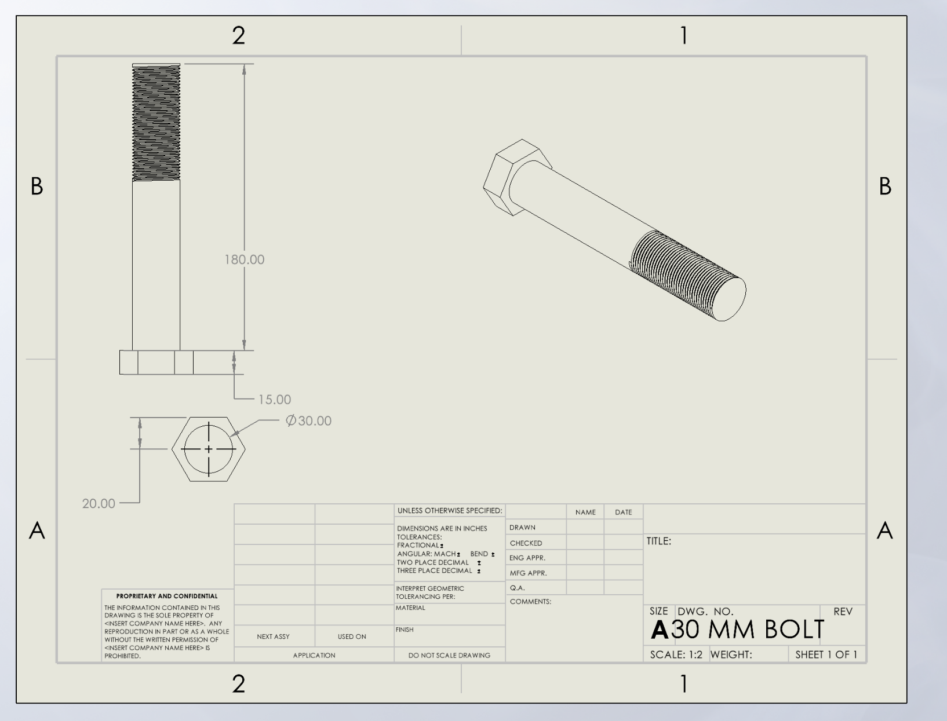

**INSERT SCREEN IMAGES OF YOUR SOLIDWORKS 3D FINAL ASSEMBLY**

